Introduction to Java

Java programming language was originally developed by Sun Microsystems which was initiated by James Gosling and released in 1995 as core component of Sun Microsystems' Java platform (Java 1.0 [J2SE]).
The latest release of the Java Standard Edition is Java SE 8. With the advancement of Java and its widespread popularity, multiple configurations were built to suit various types of platforms. For example: J2EE for Enterprise Applications, J2ME for Mobile Applications.
The new J2 versions were renamed as Java SE, Java EE, and Java ME respectively. Java is guaranteed to be Write Once, Run Anywhere.

Java is −
Object Oriented − In Java, everything is an Object. Java can be easily extended since it is based on the Object model.
Platform Independent − Unlike many other programming languages including C and C++, when Java is compiled, it is not compiled into platform specific machine, rather into platform independent byte code. This byte code is distributed over the web and interpreted by the Virtual Machine (JVM) on whichever platform it is being run on.
Simple − Java is designed to be easy to learn. If you understand the basic concept of OOP Java, it would be easy to master.
Secure − With Java's secure feature it enables to develop virus-free, tamper-free systems. Authentication techniques are based on public-key encryption.
Architecture-neutral − Java compiler generates an architecture-neutral object file format, which makes the compiled code executable on many processors, with the presence of Java runtime system.
Portable − Being architecture-neutral and having no implementation dependent aspects of the specification makes Java portable.
Robust − Java makes an effort to eliminate error prone situations by emphasizing mainly on compile time error checking and runtime checking.

Multithreaded − With Java's multithreaded feature it is possible to write programs that can perform many tasks simultaneously. This design feature allows the developers to construct interactive applications that can run smoothly.
Interpreted − Java byte code is translated on the fly to native machine instructions and is not stored anywhere. The development process is more rapid and analytical since the linking is an incremental and light-weight process.
High Performance − With the use of Just-In-Time compilers, Java enables high performance.
Distributed − Java is designed for the distributed environment of the internet.
Dynamic − Java is considered to be more dynamic than C or C++ since it is designed to adapt to an evolving environment. Java programs can carry extensive amount of run-time information that can be used to verify and resolve accesses to objects on run-time.

History of Java
James Gosling initiated Java language project in June 1991 for use in one of his many set-top box projects. The language, initially called ‘Oak’ after an oak tree that stood outside Gosling's office, also went by the name ‘Green’ and ended up later being renamed as Java, from a list of random words.
Sun released the first public implementation as Java 1.0 in 1995. It promised Write Once, Run Anywhere (WORA), providing no-cost run-times on popular platforms.
On 13 November, 2006, Sun released much of Java as free and open source software under the terms of the GNU General Public License (GPL).
On 8 May, 2007, Sun finished the process, making all of Java's core code free and open-source, aside from a small portion of code to which Sun did not hold the copyright.

Tools that Will be Needed
Linux 7.1 or Windows xp/7/8 operating system
Java JDK 8
Microsoft Notepad or any other text editor

Local Environment Setup
Right-click on 'My Computer' and select 'Properties'.

Click the 'Environment variables' button under the 'Advanced' tab.
Now, alter the 'Path' variable so that it also contains the path to the Java executable. Example, if the path is currently set to 'C:\WINDOWS\SYSTEM32', then change your path to read 'C:\WINDOWS\SYSTEM32;c:\Program Files\java\jdk\bin'.

First Java Program
public class MyFirstJavaProgram {
public static void main(String[] args) {
System.out.println("Hello Java"); // prints Hello Java
}
}
Understanding the Simple Program of Java
class keyword is used to declare a class in java.
public keyword is an access modifier which represents visibility, it means it is visible to all.
static is a keyword, if we declare any method as static, it is known as static method. The core advantage of static method is that there is no need to create object to invoke the static method. The main method is executed by the JVM, so it doesn't require to create object to invoke the main method. So it saves memory.
void is the return type of the method, it means it doesn't return any value.
main represents startup of the program.
String[] args is used for command line argument.
System.out.println() is used to print the statement.

How to save the file, compile, and run the program
Open notepad and add the code as above.
Save the file as: MyFirstJavaProgram.java.
Open a command prompt window and go to the directory where you saved the class. Assume it's C:\.
Type 'javac MyFirstJavaProgram.java' and press enter to compile your code. If there are no errors in your code, the command prompt will take you to the next line (Assumption : The path variable is set.)
Now, type ' java MyFirstJavaProgram ' to run your program.
We will be able to see ' Hello Java ' printed on the window.
Internal Details of Hello Java Program
What happens at compile time?
At compile time, java file is compiled by Java Compiler (It does not interact with OS) and converts the java code into bytecode.
public class MyFirstJavaProgram {
public static void main(String[] args) {
System.out.println("Hello Java"); // prints Hello Java
}
}

compiler
bytecode
javac

MyFirstJavaProgram.java MyFirstJavaProgram.class

What happens at Run time?
At runtime, following steps are
performed:
operating system

jvm

.class jit

Difference between JDK, JRE and JVM
JDK is an acronym for Java Development Kit.It physically exists.It contains JRE + development tools.
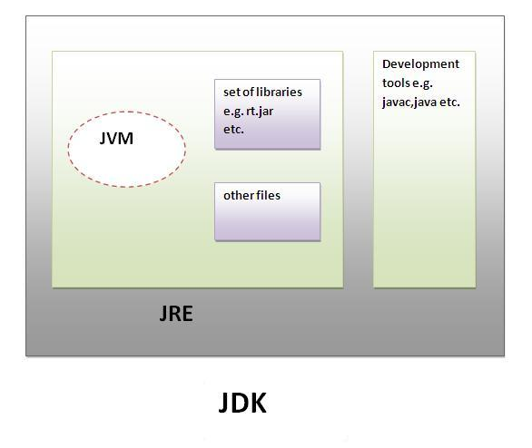
Internal Details of JVM (Java Virtual Machine)
JVM is:
A specification where working of Java Virtual Machine is specified. But implementation provider is independent to choose the algorithm. Its implementation has been provided by Sun and other companies.
An implementation Its implementation is known as JRE (Java Runtime Environment).
Runtime Instance Whenever you write java command on the command prompt to run the java class, and instance of JVM is created.
The JVM performs following operation:
Loads code
Verifies code
Executes code
Provides runtime environment

Internal Architecture of JVM
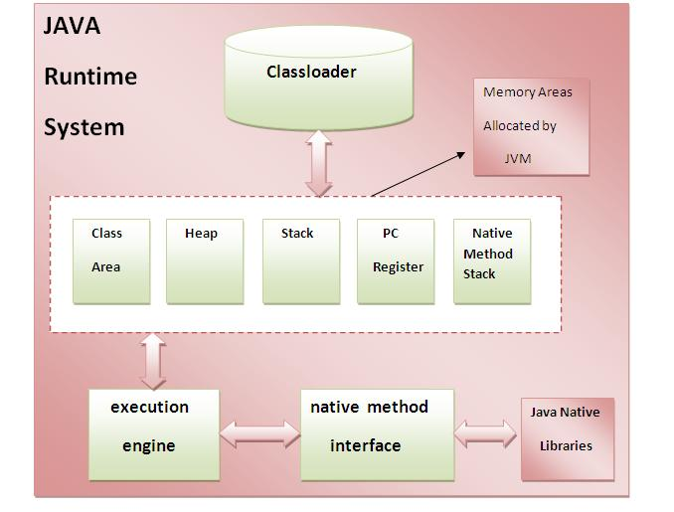
1) Classloader:
Classloader is a subsystem of JVM that is used to load class files.
2) Class(Method) Area:
Class(Method) Area stores per-class structures such as the runtime constant pool, field and method data, the code for methods.
3) Heap:
It is the runtime data area in which objects are allocated.
4) Stack:
Java Stack stores frames.It holds local variables and partial results, and plays a part in method invocation and return.Each thread has a private JVM stack, created at the same time as thread.A new frame is created each time a method is invoked. A frame is destroyed when its method invocation completes.
5) Program Counter Register:
It contains the address of the Java virtual machine instruction currently being executed.
6) Native Method Stack:
It contains all the native methods used in the application.
7) Execution Engine:
It contains:
1) A virtual processor
2) Interpreter:Read bytecode stream then execute the instructions.
3) Just-In-Time(JIT) compiler:It is used to improve the performance.JIT compiles parts of the byte code that have similar functionality at the same time, and hence reduces the amount of time needed for compilation.Here the term compiler refers to a translator from the instruction set of a Java virtual machine (JVM) to the instruction set of a specific CPU

Basic Syntax Rules
Case Sensitivity − Java is case sensitive, which means identifier Hello and hello would have different meaning in Java.
Class Names − For all class names the first letter should be in Upper Case. If several words are used to form a name of the class, each inner word's first letter should be in Upper Case.
Example: class MyFirstJavaClass
Method Names − All method names should start with a Lower Case letter. If several words are used to form the name of the method, then each inner word's first letter should be in Upper Case.Example: public void myMethodName()
Program File Name − Name of the program file should exactly match the class name.
When saving the file, you should save it using the class name (Remember Java is case sensitive) and append '.java' to the end of the name (if the file name and the class name do not match, program will not compile).Example: Assume 'MyFirstJavaProgram' is the class name. Then the file should be saved as 'MyFirstJavaProgram.java'
public static void main(String args[]) − Java program processing starts from the main() method which is a mandatory part of every Java program.

Java Identifiers
All Java components require names. Names used for classes, variables, and methods are called identifiers.In Java, there are several points to remember about identifiers. They are as follows −
All identifiers should begin with a letter (A to Z or a to z), currency character ($) or an underscore (_).
After the first character, identifiers can have any combination of characters.
A key word cannot be used as an identifier.
Most importantly, identifiers are case sensitive.
Examples of legal identifiers: age, $salary, _value, __1_value.
Examples of illegal identifiers: 123abc, -salary.

Java Modifiers
it is possible to modify classes, methods, etc., by using modifiers. There are two categories of modifiers −Access Modifiers − default, public , protected, private
Non-access Modifiers − final, abstract, strictfp

Variable
Variable is name of reserved area allocated in memory. In other words, it is a name of memory location. its value can be changed.
Java Variables Following are the types of variables in Java −
Local Variables
Class Variables (Static Variables)
Instance Variables (Non-static Variables)

Java Keywords
The following list shows the reserved words in Java. These reserved words may not be used as constant or variable or any other identifier names.

abstract | assert | boolean | break
byte | case | catch | char
class | const | continue | default
do | double | else | enum
extends | final | finally | float
for | goto | if | implements
import | instanceof | int | interface
long | native | new | package
private | protected | public | return
short | static | strictfp | super
switch | synchronized | this | throw
throws | transient | try | void
volatile | while

variable types.
Local variables − Variables defined inside methods, constructors or blocks are called local variables. The variable will be declared and initialized within the method and the variable will be destroyed when the method has completed.
Instance variables − Instance variables are variables within a class but outside any method. These variables are initialized when the class is instantiated. Instance variables can be accessed from inside any method, constructor or blocks of that particular class.
Class variables − Class variables are variables declared within a class, outside any method, with the static keyword.

Data Types in Java
Data types represent the different values to be stored in the variable. In java, there are two types of data types:

Primitive data types
Non-primitive data types
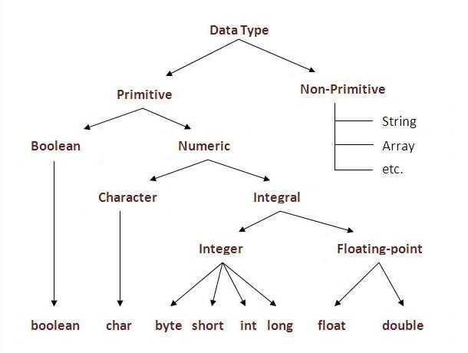

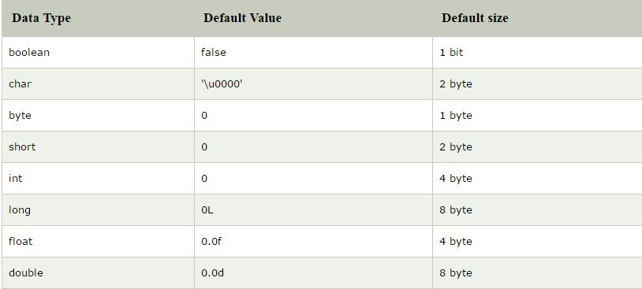

Operators in java
Operator in java is a symbol that is used to perform operations. For example: +, -, *, / etc.There are many types of operators in java which are given below:

Unary Operator,
Arithmetic Operator,
shift Operator,
Relational Operator,
Bitwise Operator,
Logical Operator,
Ternary Operator and
Assignment Operator.
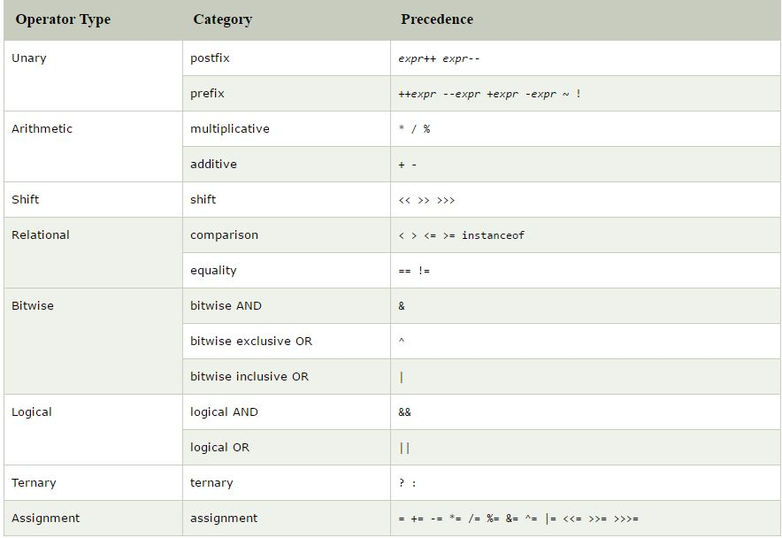

Java Unary Operator Example: ++ and --

class OperatorExample1{
public static void main(String args[]){
int x=10;
System.out.println(x++);//10 (11)
System.out.println(++x);//12
System.out.println(x--);//12 (11)
System.out.println(--x);//10
}}
Output:
10
12
12
10
========================================================================
Java Unary Operator Example 2: ++ and --
class OperatorExample2{
public static void main(String args[]){
int a=10;
int b=10;
System.out.println(a++ + ++a);//10+12=22
System.out.println(b++ + b++);//10+11=21

}}
Output:

22
21
=====================================================================================
Java Unary Operator Example: ~ and !
class OperatorExample3{
public static void main(String args[]){
int a=10;
int b=-10;
boolean c=true;
boolean d=false;
System.out.println(~a);//-11 (minus of total positive value which starts from 0)
System.out.println(~b);//9 (positive of total minus, positive starts from 0)
System.out.println(!c);//false (opposite of boolean value)
System.out.println(!d);//true
}}
Output:
-11
9
false
true
=====================================================================================
Java Arithmetic Operator Example
class OperatorExample4{
public static void main(String args[]){
int a=10;
int b=5;
System.out.println(a+b);//15
System.out.println(a-b);//5
System.out.println(a*b);//50
System.out.println(a/b);//2
System.out.println(a%b);//0
}}
Output:
15
5
50
2
0
==================================================================================
Java Arithmetic Operator Example: Expression
class OperatorExample5{
public static void main(String args[]){
System.out.println(10*10/5+3-1*4/2);
}}
Output:
=====================================================================================
Java Shift Operator Example: Left Shift
class OperatorExample6{
public static void main(String args[]){
System.out.println(10<<2);//10*2^2=10*4=40
System.out.println(10<<3);//10*2^3=10*8=80
System.out.println(20<<2);//20*2^2=20*4=80
System.out.println(15<<4);//15*2^4=15*16=240
}}
Output:
40
80
80
240
==================================================================================
Java Shift Operator Example: Right Shift
class OperatorExample7{
public static void main(String args[]){
System.out.println(10>>2);//10/2^2=10/4=2
System.out.println(20>>2);//20/2^2=20/4=5
System.out.println(20>>3);//20/2^3=20/8=2
}}
Output:
2
5
2
====================================================================================
Java Shift Operator Example: >> vs >>>
class OperatorExample8{
public static void main(String args[]){
//For positive number, >> and >>> works same
System.out.println(20>>2);
System.out.println(20>>>2);
//For negative number, >>> changes parity bit (MSB) to 0
System.out.println(-20>>2);
System.out.println(-20>>>2);
}}
Output:
5
5
-5
1073741819
=====================================================================================
Java AND Operator Example: Logical && and Bitwise &
The logical && operator doesn't check second condition if first condition is false. It checks second condition only if first one is true. The bitwise & operator always checks both conditions whether first condition is true or false.

class OperatorExample9{
public static void main(String args[]){
int a=10;
int b=5;
int c=20;
System.out.println(a<b&&a<c);//false && true = false
System.out.println(a<b&a<c);//false & true = false
}}
Output:
false
false
Java AND Operator Example: Logical && vs Bitwise &
class OperatorExample10{
public static void main(String args[]){
int a=10;
int b=5;
int c=20;
System.out.println(a<b&&a++<c);//false && true = false
System.out.println(a);//10 because second condition is not checked
System.out.println(a<b&a++<c);//false && true = false
System.out.println(a);//11 because second condition is checked
}}
Output:
false
10
false
11
Java OR Operator Example: Logical || and Bitwise |
The logical || operator doesn't check second condition if first condition is true. It checks second condition only if first one is false.The bitwise | operator always checks both conditions whether first condition is true or false.
class OperatorExample11{
public static void main(String args[]){
int a=10;
int b=5;
int c=20;
System.out.println(a>b||a<c);//true || true = true
System.out.println(a>b|a<c);//true | true = true
//|| vs |
System.out.println(a>b||a++<c);//true || true = true
System.out.println(a);//10 because second condition is not checked
System.out.println(a>b|a++<c);//true | true = true
System.out.println(a);//11 because second condition is checked
}}
Output:
true
true
true
10
true
11
=====================================================================================
Java Assignment Operator Example
class OperatorExample14{
public static void main(String args[]){
int a=10;
int b=20;
a+=4;//a=a+4 (a=10+4)
b-=4;//b=b-4 (b=20-4)
System.out.println(a);
System.out.println(b);
}}
Output:
14
16

=====================================================================================
Java Assignment Operator Example
class OperatorExample15{
public static void main(String[] args){
int a=10;
a+=3;
System.out.println(a);
a-=4;
System.out.println(a);
a*=2;
System.out.println(a);
a/=2;
System.out.println(a);
}}
Output:
13
9
18
9
=====================================================================================
After type cast:
class OperatorExample17{
public static void main(String args[]){
short a=10;
short b=10;
a=(short)(a+b);//20 which is int now converted to short
System.out.println(a);
}} Output:20

